Lab 2: Hugging Face – Sentiment Analysis using Transformers

Experiment Title
Lab2: Hugging Face – Sentiment Analysis Application using Transformers and Gradio

Objective
The objective of this experiment is to build a simple Sentiment Analysis web application using a pre-trained Hugging Face Transformer model and deploy it locally using Gradio. The application analyzes user input text and classifies it as Positive or Negative sentiment along with a confidence score.

Tools and Technologies Used
- Programming Language: Python
- Libraries:
  - transformers
  - gradio
- Model: Pre-trained Sentiment Analysis Transformer (from Hugging Face)
- Platform: Local machine / Google Colab
- Hardware: CPU

Theory
Hugging Face provides a wide range of pre-trained transformer models for Natural Language Processing tasks such as sentiment analysis, text classification, summarization, and translation.
Sentiment Analysis is a supervised NLP task where text is classified based on emotional tone. The Hugging Face pipeline() API simplifies this process by abstracting model loading, tokenization, and inference into a single function call.
Gradio is a Python library that allows quick creation of web-based user interfaces for machine learning models. It enables real-time interaction with models using text boxes, buttons, and outputs without requiring frontend development.

Algorithm / Workflow
- Install required libraries (transformers and gradio)
- Import necessary modules
- Load a pre-trained sentiment analysis model using Hugging Face pipeline
- Define a function to analyze user input text
- Create a Gradio interface with input and output components
- Launch the application locally
- Test the application with different text inputs

Implementation(Code) :
# Step 1: Install the necessary libraries
!pip install -q transformers gradio

# Step 2: Import libraries
from transformers import pipeline
import gradio as gr

# Step 3: Load the sentiment analysis pipeline
classifier = pipeline("sentiment-analysis")

# Step 4: Define a function for sentiment analysis
def analyze_text(text):
result = classifier(text)[0]
return f"Label: {result['label']}, Score: {round(result['score'], 4)}"

# Step 5: Create the Gradio interface
demo = gr.Interface(
fn=analyze_text,
inputs="text",
outputs="text",
title="My First AI Sentiment App",
description="Type a sentence below to see if it's Positive or Negative!"
)

# Step 6: Launch the app
demo.launch(share=True)

Output
- The application provides a web-based interface.
- Users can input any sentence.
- The model outputs:
  - Sentiment Label: POSITIVE or NEGATIVE
  - Confidence Score: Probability score indicating prediction confidence
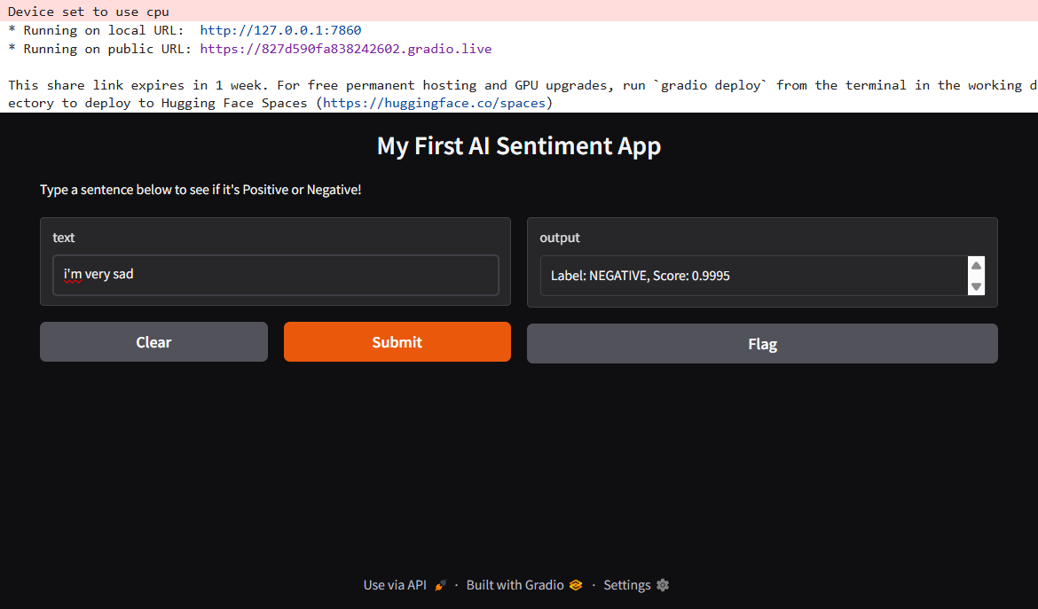

Result
The sentiment analysis application was successfully implemented using Hugging Face Transformers and Gradio. The model accurately classified input text into positive or negative sentiment and displayed the confidence score through an interactive web interface.
Conclusion
This experiment demonstrates how powerful pre-trained transformer models can be easily integrated into real-world applications using Hugging Face and Gradio. The pipeline-based approach reduces development complexity and enables rapid deployment of NLP models without extensive training or frontend development.

Applications
- Customer feedback analysis
- Social media sentiment monitoring
- Product review classification
- Chatbot emotion detection

Future Enhancements
- Add multi-class sentiment analysis (neutral, mixed)
- Support multiple languages
- Deploy the application on Hugging Face Spaces
- Store sentiment history in a database

References
- Hugging Face Documentation
- Transformers Library – Hugging Face
- Gradio Documentation

